Q1.
For creating the three tables of Train, Validate and Test, Random numbers have been generated in R using the following code.
S < - seq (1:4000)
T <- sample (s, replace=FALSE)
Now first 1800 are used for Train, next 1400 for validate and next 800 for Test.
########################## Part a ##################################
Code :
CBC<-read.csv("C:\\satish\\IIMA\\Acads\\Term4\\AMDA\\End term\\Q1\\CBCTrain.csv")
attach(CBC)
names(CBC)
cbc.glm <-glm(Florence~Seq+ID+Gender+Monetary+Recency+Frq+FirstPurch+ChildBks+YouthBks+CookBks+DoItYBks+RefBks+ArtBks+GeogBks+ItalCook+ItalAtlas+ItalArt+RelatedPurchase,family=binomial)
summary (cbc.glm)

1st Iteration : summary ::
Coefficients: (1 not defined because of singularities)
Estimate Std. Error z value Pr(>|z|)
(Intercept) -2.2107213 0.3412410 -6.478 9.27e-11 ***
Seq -0.0019097 0.0058249 -0.328 0.743021
ID 0.0002211 0.0007094 0.312 0.755254
Gender -0.4892978 0.1751703 -2.793 0.005218 **
Monetary -0.0014161 0.0010174 -1.392 0.163964
Recency 0.0076452 0.0168629 0.453 0.650278
Frq 0.2786325 0.0729431 3.820 0.000134 ***
FirstPurch -0.0004542 0.0125805 -0.036 0.971199
ChildBks -0.2147895 0.1197662 -1.793 0.072908 .
YouthBks -0.4028030 0.1783519 -2.258 0.023916 *
CookBks -0.4220685 0.1224937 -3.446 0.000570 ***
DoItYBks -0.3464999 0.1572953 -2.203 0.027604 *
RefBks -0.2212169 0.1723436 -1.284 0.199289
ArtBks 0.3403861 0.1128345 3.017 0.002556 **
GeogBks 0.2148301 0.1116707 1.924 0.054382 .
ItalCook -0.4103347 0.2635306 -1.557 0.119455
ItalAtlas 0.0738876 0.4022057 0.184 0.854244
ItalArt 0.1122657 0.3707701 0.303 0.762049
RelatedPurchase NA NA NA NA

Removing variables RelatedPurchase, Seq, ID, FirstPurch,ItalAtlas, ItalArt, Refbks etc in the sequential order of higher p_value.

Final model with significant variables : glm(formula = Florence ~ Gender + Frq + YouthBks + CookBks + DoItYBks + ArtBks + GeogBks, family = binomial)

Diagnostics : @ 8% level of significance
If 3% level of significance is taken then we may need to remove DoItYBks, but I am going ahead with 8% level of significance. As given below AIC and null deviance values are 1056.7 and 1093.8, which are good.

Deviance Residuals:
Min 1Q Median 3Q Max
-1.0107 -0.4514 -0.3793 -0.3347 2.6428

Coefficients:
Estimate Std. Error z value Pr(>|z|)
(Intercept) -2.48352 0.16917 -14.681 < 2e-16 ***
Gender -0.45024 0.17328 -2.598 0.009369 **
Frq 0.16911 0.03957 4.273 1.93e-05 ***
YouthBks -0.31024 0.16640 -1.864 0.062258 .
CookBks -0.38168 0.11226 -3.400 0.000674 ***
DoItYBks -0.25830 0.14723 -1.754 0.079377 .
ArtBks 0.36168 0.10958 3.301 0.000965 ***
GeogBks 0.21432 0.10492 2.043 0.041080 *
---
Signif. codes: 0 ‘***’ 0.001 ‘**’ 0.01 ‘*’ 0.05 ‘.’ 0.1 ‘ ’ 1

(Dispersion parameter for binomial family taken to be 1)

Null deviance: 1093.8 on 1799 degrees of freedom
Residual deviance: 1040.7 on 1792 degrees of freedom
AIC: 1056.7

Number of Fisher Scoring iterations: 5
######################################### PART B #########################################################
# Drawing the ROC curve.
predval<-predict(cbc.glm,type="response")
precision <- 0.005
thres <- seq(0,1,by=precision)
len <- length(thres)
error <- rep(0, len)
sensitivity <- rep(0,len)
nspecificity <- rep(0,len)
len2 <- length(predval)
Florence_good <- sum(Florence)
Florence_bad <- length(Florence) -Florence_good
for (i in 1:len ) {
digpred <- rep(0,len2)
bad_good <- 0
good_good <- 0
good_bad <- 0
bad_bad <- 0
for (j in 1:len2 ) {
if (predval[j] > thres[i]) {
digpred[j] <- 1
if (Florence[j] != 1) {
error[i] <- error[i] +1
bad_good <- bad_good +1}
else {
good_good <- good_good +1 }}
else {
digpred[j] <- 0
if (Florence[j] != 0) {
error[i] <- error[i] +1
good_bad <- good_bad +1}
else {
bad_bad <- bad_bad +1 }}}
sensitivity[i] <- good_good /(good_good + good_bad)
nspecificity[i] <- bad_good / (bad_good + bad_bad) }
plot (nspecificity, sensitivity)
times <- length(nspecificity) -1
roc_area <- 0
for ( k in 1 : times ) {
roc_area <- roc_area + ( 0.5 * ( sensitivity[k] + sensitivity [k+1] ) * ( nspecificity [k] - nspecificity[k+1] ))} roc_area

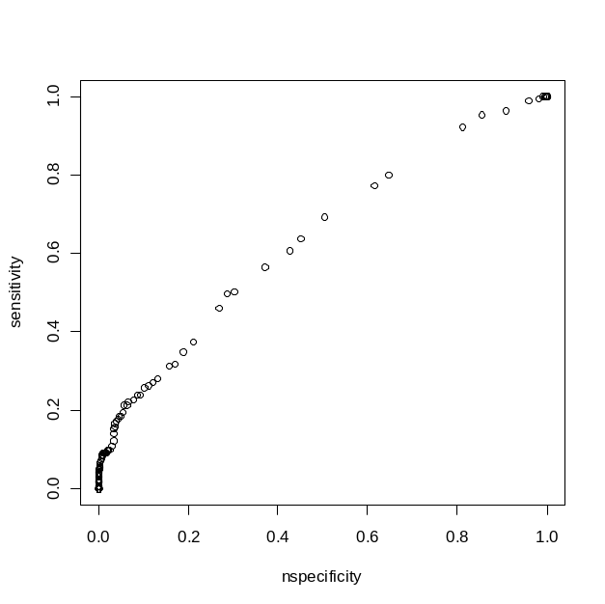
Diagnostics : Area under ROC value of Model 0 is 0.64 , which shows that the model discriminates, but not within acceptable limits as Area under ROC curve is <0.7
################ Part C ##################################################
misclassification_cost <- (c01 * bad_good)+(c10 * good_bad )
plot (thres, misclassification_cost )
thres[which.min(misclassification_cost)]

For given mis-classification costs of c01 = 1 ; c10 = 40 , total misclassification cost is lower when the threshold is 0.03.
Usually we reduce the total number of mis-classifications which is equivalent to c01 =1 and c10 =1 , that gives a optimal threshold value of 0.37
Since there is very heavy weight -age for c10, which is a heavy penalty for losing out responders,the threshold is going very low (0.03).

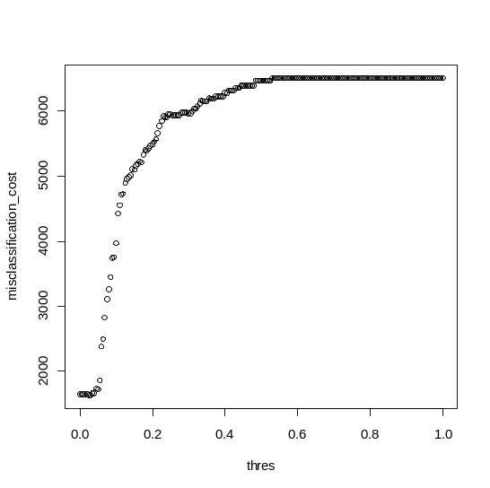

Applying on validation set.
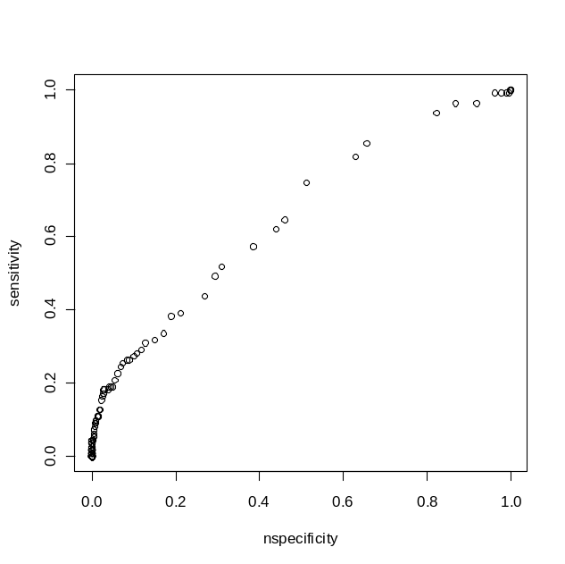
Roc area : 0.65673 , So still discrimination is not significant enough
Optimal Threshold for given misclassification costs on validation set is : 0.04

########################## Part D ###############################
Code : This is repeated for all the five models with indices varying from 1 to 5.
CBC<-read.csv("C:\\satish\\IIMA\\Acads\\Term4\\AMDA\\End term\\Q1\\CBCTrain1.csv")
attach(CBC)
names(CBC)
cbc.glm1 <- glm(formula = Florence ~ Gender + Frq + YouthBks + CookBks + ArtBks + GeogBks, family = binomial)
predval1<-predict(cbc.glm1,data.frame(Gender=Gender, Frq=Frq , YouthBks=YouthBks, CookBks=CookBks,DoItYBks=DoItYBks, ArtBks=ArtBks,GeogBks=GeogBks), family = binomial, type="response")

predval <- predval1
Results of models :
 | Model0 | Model1 | Model2 | Model3 | Model4 | Model5
ROC Area | 0.64099 | 0.48605 | 0.47565 | 0.51033 | 0.48047 | 0.64215
Threshold | 0.03 | 0.015 | 0.03 | 0.025 | 0.035 | 0.045

######################## Part E ###################################
Code :
len2 <- length(Florence)
thres <- c(0.015,0.03,0.025,0.035,0.045)
cpredval <- cbind (predval1,predval2,predval3,predval4,predval5)
len <- length(thres)
error <- rep(0, len)
sensitivity <- rep(0,len)
nspecificity <- rep(0,len)
bad_good <- rep(0,len)
good_good <- rep(0,len)
good_bad <- rep(0,len)
bad_bad <- rep(0,len)
misclassification_cost <- rep(0,len)
c01 <- 1
c10 <- 40
for (i in 1:len ) {
digpred <- rep(0,len2)
predval <- cpredval[,i]
for (j in 1:len2 ) {
if (predval[j] > thres[i]) {
digpred[j] <- 1
if (Florence[j] != 1) {
error[i] <- error[i] +1
bad_good[i] <- bad_good[i] +1}
else {
good_good[i] <- good_good[i] +1 }}
else {
digpred[j] <- 0
if (Florence[j] != 0) {
error[i] <- error[i] +1
good_bad[i] <- good_bad[i] +1}
else {
bad_bad[i] <- bad_bad[i] +1 }}}
misclassification_cost[i] <- (c01 * bad_good[i])+(c10 * good_bad[i] )}

Results of all models when run on validation data set.
 | Model0 | Model1 | Model2 | Model3 | Model4 | Model5
Valid-ROC Area | 0.65673 | 0.64103 | 0.66426 | 0.66764 | 0.66859 | 0.65752
Valid-Theshold | 0.04 | 0.025 | 0.04 | 0.035 | 0.035 | 0.045

Performance of all 5 models on validation det
 | Model1 | Model2 | Model3 | Model4 | Model5
Misclassification cost | 1288 | 1279 | 1281 | 1269 | 1266
Error | 1288 | 1279 | 1281 | 1269 | 1266

We can observe that for the thresholds reported in part d, the models always try to minimize c10 errors, and so all the errors are of type c01, and model 5 is the best performer

######################## Part F ####################################
Performance of all models on validation set. In this case model 6 is bad, since atleast 3 models on an average predict a responder , which gives all 1’s for all trials as part of model 6. So this model has higher misclassification cost.

 | Model0 | Model1 | Model2 | Model3 | Model4 | Model5 | Model6
Misclassification cost | 1317 | 1288 | 1279 | 1281 | 1269 | 1266 | 1290
Error | 1278 | 1288 | 1279 | 1281 | 1269 | 1266 | 1290

##################### Part G #######################################
Applying model 5 on test data.

Misclassification cost : 765
Errors : 726, That means there is on c10 error, which costed 40.
Code for Part F and G :
len2 <- length(Florence)
thres <- c(0.015,0.03,0.025,0.035,0.045)
cpredval <- cbind (predval1,predval2,predval3,predval4,predval5)
len <- length(thres)
error <- rep(0, len)
sensitivity <- rep(0,len)
nspecificity <- rep(0,len)
bad_good <- rep(0,len)
good_good <- rep(0,len)
good_bad <- rep(0,len)
bad_bad <- rep(0,len)
misclassification_cost <- rep(0,len)
cdigpred <- array(0,dim=c(len2,len))
c01 <- 1
c10 <- 40
for (i in 1:len ) {
digpred <- rep(0,len2)
predval <- cpredval[,i]
for (j in 1:len2 ) {
if (predval[j] > thres[i]) {
digpred[j] <- 1
if (Florence[j] != 1) {
error[i] <- error[i] +1
bad_good[i] <- bad_good[i] +1}
else {
good_good[i] <- good_good[i] +1 }}
else {
digpred[j] <- 0
if (Florence[j] != 0) {
error[i] <- error[i] +1
good_bad[i] <- good_bad[i] +1}
else {
bad_bad[i] <- bad_bad[i] +1 }}}
cdigpred[,i] <- digpred
misclassification_cost[i] <- (c01 * bad_good[i])+(c10 * good_bad[i] )}
### part f ########### model 6
predval6 <- seq(0,len2)
for ( j in 1 : len2 ) {
if (sum(cdigpred[1,]) >3) {
predval6[j] <- 1}}
predval6 <- predval6[1:1400]

Q2. ## part A ###
Doing a hypothesis testing for the difference in the means.
ho : u0 =u1, vs h1: u0 ne u1 , where u0 an u1 are means of sizes of female crabs in capture recapture and other way of catching.
Assumptions : Normality of the data in both the case
Validating using Shapiro wilkinson’s test .
Shapiro.test(capture)
W = 0.9335, p-value = 3.226e-05
shapiro.test(wild)
W = 0.8333, p-value < 2.2e-16
So normality assumptions hold good.
And the pvalue for the hypothesis test gives a pvalue of 1, which shows the two means are statistically different, ie, capture recapture crab size is different form lab test.
### part B ####
Again a hypothesis testing for H0: u0-u1 =0 vs H1 : u0 not equal u1
Assumption normality of molt size increase; Shapiro tests yield p-values of .0002625 and 0.09, which show one of the data is not normally distributes since it has 9% p-value; Proceeding ahead.
P-value of the difference in means of increase in molt size gives p-value of 0.9999, which shows the difference in means is significant. So molt size increase is different in the two different segments.(lab test and cap-recapt).
Code :
nsim <- 1000
capture<- c(127.7,133.2,135.3,143.3,139.3,140.2,143.8,144.6,147.6,144.8,146.8,145.9,151,148.7,147.8,148.3,149.2,149,149.2,148.7,149,151.1,150.4,149.4,150,151,150,150.7,147.6,151.9,151.5,151.1,151,151.8,150.9,150,154,152.6,152.6,152.6,151.1,151.4,155,151.8,154.2,154,151.9,155.5,155.9,153.1,155.4,154.2,153,151.7,153.4,154,155.6,156.2,155.6,154.3,158.2,155.6,156.5,157.3,155.8,156.6,155.9,156.6,155,158.2,158.7,155.9,159.1,155.6,158.6,154.3,161.6,157,154.6,157.9,160,159.9,157.1,159.9,157,159.6,160.6,155.6,159.6,162.7,158.3,160.1,163.7,163.2,164.7,163.5,166.5,130.8,141.6,142.5,147.5,151.4,154.2,152.3,159.5,156.6,154.6,157.8,161.7,160.6,156)
shapiro.test(capture)
caplen <- length(capture)
wild<- c(154.8,142.5,154.9,136.5,146.6,151.5,154.4,152.2,155.3,133.3,149.7,157.5,155.3,152.9,154.3,143.1,145.2,135.4,153.5,148.9,139.1,155.4,154.7,149.5,151.5,160.1,153.2,142,153.8,164.9,155.7,155.8,158.9,155.2,164.1,161.3,156.7,148.2,156.5,147.8,157.7,149.1,151.5,146.7,148.5,156.6,155,129.5,101.4,128.9,101.9,105.1,114.8,91.5,96.4,94.5,131.1,93.8,101.3,95.5,82.3,97.2,92.1,96.3,104.6,38.8,51.8,110.2,120,121.9,134.8,148,158.2,154.8,141.8,141.6,146.6,133.8,136.5,140.9,140.4,148.5,145.8,142.8,142.4,149.1,149.5,127.6,136.2,145.8,154.2,147.1,159.4,162.6,151.5,118,145.5,148.2,135.9,136.1,128.6,139.8,136.7,135.1,149,163.7,149.8,143.2,143.2,157,152.7,153.6,140.6,151.7,132,132.5,154.5,143.3,138.1,126.7,132.4,149.3,139.3,151.5,166.8,126.8,152.1,126.9,145.4,156.3,142.7,132.9,137.9,126.1,160.4,166.2,145.4,144.3,156.8,131.2,140.8,130.8,149.7,156.7,136.1,150.1,140.7,139.4,160.1,138.2,148.6,152,128.2,126.7,142.5,139.7,151.8,141.1,140.7,157.5,143.8,127.7,155.2,146.9,125,133.5,144.4,154.6,154.4,138.6,133.7,153.2,159.1,149.5,144.7,147.3,138.4,136.9,146.6,124.5,144.1,124.4,142.2,134.1,133.8,127.8,132.3,135.6,130.3,128.7,118.8,133.4,151.6,140.6,144.6,147.7,154.8,139.1,124.2,129.5,123.7,130.6,134.7,153.9,148.4,130.1,135.8,140.3,138.7,140.6,127.6,127.7,127.5,138.3,127.3,151.5,140.5,128.5,145.9,135.5,125.4,146.3,144.5,148.8,127.8,137.7,149.6,128,141.8,138.5,136.1,130.1,139.2,153.4,141.6,138.6,153,139.8,140.8,138,146.7,135.9,144.4,138.5,125.3,131.9,134.3,147.8,147.7,144.2,132,136.1,148.1,147.5,122.4,147.7,144.2,132,136.1,148.1,147.5,122.4,135.8,135.2,126.5,140.3,145.8,152.1,147,150.4,155.7,140.5,139.3,131.5,142.7,158.2,135.8,147.2,150,148.2,139.8,143.7,141.3,147.2,139.7,130.3,149.3,150.4,160,161.6,149.3,129.2,142.7,143.6,132,133.2,137.8,145.4,150.8,147.2,143.7,144.7,148.1,135.4,145.8,154.2,144.3,133.7,155.4,142.4,149.5,157.1,147.6,143.5,138.9,157,140.8,156.4,153.1,152.3,130.5,149.8,142.3,153.4,147.9,149.9,152.2,150.4,141.8,152.4,133.7,147.1,151.7,153.6,145.2,141.6,138.3,135.2,153.5,153.3,151.6,152.9,147.5,141.9,145.9,140.3,148.5,151.4,138.6,146.4,134.3,154.1,146.4,149.4,134.7,161.7,150.3,151.2,143.5,148.3,129.2)
shapiro.test(wild)
wildlen <- length(wild)
capm <- mean(capture)
wildm <- mean(wild)
wildbm <- rep(0,nsim)
capbm <- rep(0,nsim)
# boot strap
for (i in 1 : nsim) {
wildb <- sample (wild,replace=T)
wildbm[i] <- mean(wildb)
capb <- sample (capture,replace=T)
capbm[i] <- mean(capb)}
wildstd <- sd(wildbm)
capstd <- sd(capbm)
# hypothesis testing , pvalue calculation
theta <- (capm-wildm)/sqrt(((wildstd^2))+((capstd^2)))
pval <- pnorm(theta)
### part b ####
wild<- c(14.1,15.1,15.4,17.1,12.6,12.9,15.6,15.1,17.1,13.2,15.1,13.7,18.6,15.9,15,14.7,15.4,14.9,14.9,14.1,13.8,15.9,14.9,13.8,13.9,14.8,13.7,14.3,10.9,15.1,14.6,13.8,13.6,14.2,13.3,12.4,16,14.4,14.3,14.3,12.8,12.9,16.1,12.6,14.7,14.5,11.9,15.4,15.7,12.8,15.1,13.6,12.3,10.7,12.1,12.7,14.3,14.9,14.1,12.3,16.2,13.3,14.2,14.9,13.1,13.7,12.9,13.5,11.5,14.6,15,12.2,15.4,11.7,14.6,9.8,17,12.4,9.9,12.9,14.8,14.5,11.7,14.2,11.3,13.9,14.7,9.6,12.4,15.3,10.7,12.1,15.6,15.1,13.7,12.3,12.6,15.2,18.6,18.1,11.4,14.5,15.6,12.6,19.7,15.3,10.9,13.6,15.3,12.8,8.1)
capture<-c(12.5,17.4,14.1,14.1,13.4,12.6,11.3,12.5,14.9,16.7,12.3,14.5,12.1,12.1,13.6,12.3,13.4,14.8,13.4,15.9,16.2,12.4,15.2,12,14.8,14.2,10.1,13.5,12.7,14,11.1,12.5,12.4,11.7,13.9,13,13.6,12.5,13.1,14.8,14.5,12.1,10.7,13.9,13.8,14.2,13.8,17.6,17.1,19.1,18.1,19,22.8,20.1,18.5,19.3,18,22.4,19.9,20.7,19.6,21.4,17.9,23.9,21,7.7,11.3,21.9,21.8,19.8,18.7,12.4,15,11.9,18.4,16.1,17.1,13.7,14,17.6,12.6,13.8,17.2,18.6,16.9,17.7,13.4,17,13.9,11.7,15.9,13.8,9.6,13.4,9,13.4,18.4,18.4,14.8,16.9,17.7,17.3,17.4,16.9,11.5,14.8,18.5,16.3,13.9,12.7,15.5,14.6,17.3,13.3,20.3,15.3,12.5,13.3,15.8,12,13.1,17.6,19,15.3,12.3,17.3,12.9,18.6,16.9,11.8,19.4,15.2,18.2,12.5,12.2,11.1,14.4,12.1,11.9,18.7,16.7,16.9,14.2,14.3,14.8,13.4,18.7,13.8,10.2,14.9,15,13.2,17.5,15.2,17.7,13.5,13.2,15.9,14.5,12.4,17.8,17.2,14.7,18.3,21.1,14.6,13.4,13.2,15.2,18.8,18.7,13.4,14.6,14.8,18.6,16.9,17.6,17.7,14.3,18.2,18.4,16.8,13.7,14.6,17.6,15.5,16.7,16.6,16.7,17.1,6.1,15.9,15.3,15.4,15.7,15.7,14.4,17.5,15.6,17.7,16.5,14.7,13.3,16.5,14.7,14.4,13.6,14.1,13.2,12.3,14.7,16.9,16.5,13,16.4,13.8,13.9,16.5,15.4,15.9,16.6,13.4,18.5,18,15.9,17,13.9,15.4,18.7,17.5,16.2,16.5,16.5,13.4,16.1,16.5,12.3,12.8,13.2,15.4,11.7,16.5,14,13.5,16.4,17.1,12.7,13,13.8,16.1,16.7,15.2,17.9,14.8,14.4,13.8,16.1,16.7,15.2,17.9,14.8,14.4,17.1,15.2,17.4,16.2,12.6,12.5,13.1,13.2,12.6,11.7,17.6,15.2,12.6,11.8,16.9,14.3,14.8,13.2,14.4,17,16.3,14,15.4,15,12.5,12.8,12.5,14.1,13.3,15.9,16.4,14,15.7,16.6,16.9,14.4,14.3,13.9,11.7,13.3,12.3,16.8,16,13,12.3,15,13.9,11.7,11.8,14.1,12.9,12.3,13,12.2,12.3,13,11.4,13.1,14.7,12.6,11.3,11.5,14.5,15.6,14.3,11.8,11,14.3,11.8,10.2,13.1,12.2,13,17.1,12.6,15.9,12.8,13.7,12,14.9,12.7,17.5,13.3,15.2,13.2,12.3,8.9,11.5,15.6,15.8,15.2,14.2,15.3,13.6,14.4,15.6,13.9,14.2,14.8)
shapiro.test(capture)
shapiro.test(wild)
caplen <- length(capture)
wildlen <- length(wild)
capm <- mean(capture)
wildm <- mean(wild)
wildbm <- rep(0,nsim)
capbm <- rep(0,nsim)
# boot strap
for (i in 1 : nsim) {
wildb <- sample (wild,replace=T)
wildbm[i] <- mean(wildb)
capb <- sample (capture,replace=T)
capbm[i] <- mean(capb)}
wildstd <- sd(wildbm)
capstd <- sd(capbm)
# hypothesis testing , pvalue calculation
theta <- (capm-wildm)/sqrt(((wildstd^2))+((capstd^2)))
pval <- pnorm(theta)

## part C ############
Using bootstrap method to find the 95% quantile method : 0.5026 , 0.60497
Code :
prop<-c(1,1,1,1,1,1,1,1,1,1,1,1,1,1,1,1,1,1,1,1,1,1,1,1,1,1,1,1,1,1,1,1,1,1,1,1,1,1,1,1,1,1,1,1,1,1,1,1,1,1,1,1,1,1,1,1,1,1,1,1,1,1,1,1,1,1,1,1,1,1,1,1,1,1,1,1,1,1,1,1,1,1,1,1,1,1,1,1,1,1,1,1,1,1,1,1,1,1,1,1,1,1,1,1,1,1,1,1,1,1,1,1,1,1,1,1,1,1,1,1,1,1,1,1,1,1,1,1,1,1,1,1,1,1,1,1,1,1,1,1,1,1,1,1,1,1,1,1,1,1,1,1,1,1,1,1,1,1,1,1,1,1,1,1,1,1,1,1,1,1,1,1,1,1,1,1,1,1,1,1,1,1,1,1,1,1,1,1,1,1,1,1,1,1,1,1,1,1,1,1,1,0,0,0,0,0,0,0,0,0,0,0,0,0,0,0,0,0,0,0,0,0,0,0,0,0,0,0,0,0,0,0,0,0,0,0,0,0,0,0,0,0,0,0,0,0,0,0,0,0,0,0,0,0,0,0,0,0,0,0,0,0,0,0,0,0,0,0,0,0,0,0,0,0,0,0,0,0,0,0,0,0,0,0,0,0,0,0,0,0,0,0,0,0,0,0,0,0,0,0,0,0,0,0,0,0,0,0,0,0,0,0,0,0,0,0,0,0,0,0,0,0,0,0,0,0,0,0,0,0,0,0,0,0,0,0,0,0,0,0,0,0,0,0,0,0,0,0,0,0,0,0,0,0,0,0,0,0,0,0,0,0)
plen <- length(prop)
mp <- sum(prop)
wildbm <- rep(0,nsim)
for (i in 1 : nsim) {
wildb <- sample (prop,replace=T)
wildbm[i] <- sum(wildb)/plen}
cat ("95% confid interval",quantile(wildbm,0.025),quantile(wildbm,0.975))

## part D ######
First building a regression equation.
From first iteration, removing outliers 105, and 457
Code :
crab<-read.csv("C:\\satish\\IIMA\\Acads\\Term4\\AMDA\\End term\\Q2\\crab.csv")
attach(crab)
names(crab)
crab.lm <-lm(inc~postsz)
summary(crab.lm)
par(mfrow=c(2,2))
plot(crab.lm,residuals=F,pch=16)

# using gam..
crab.gam <- gam( inc ~ s(postsz))
summary(crab.gam)
par(mfrow=c(2,2))
plot(crab.gam,residuals=F,pch=16)
plot(fitted(crab.gam),residuals(crab.gam))
qqnorm(residuals(crab.gam))
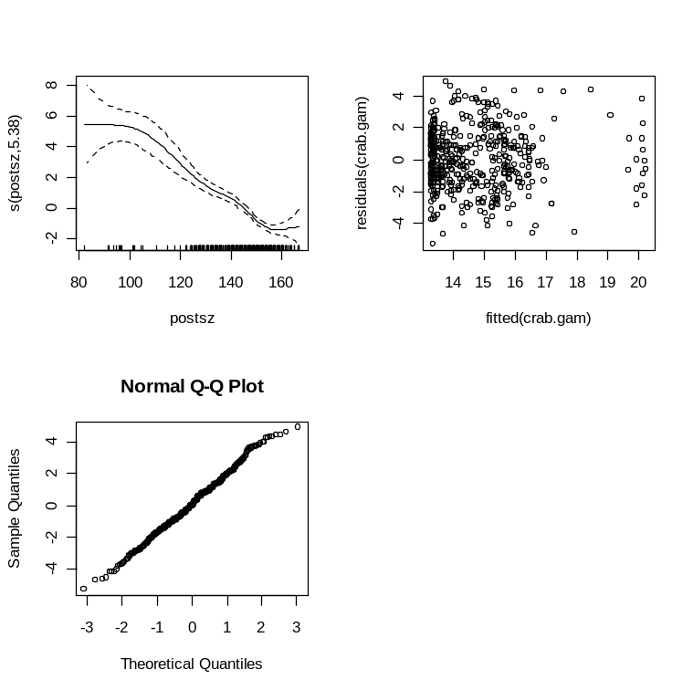
Diagnostics : Parametric coefficients:
Estimate Std. Error t value Pr(>|t|)
(Intercept) 14.72805 0.08668 169.9 <2e-16 ***
---
Signif. codes: 0 ‘***’ 0.001 ‘**’ 0.01 ‘*’ 0.05 ‘.’ 0.1 ‘ ’ 1
Approximate significance of smooth terms:
edf Est.rank F p-value
s(postsz) 5.38 9 32.02 <2e-16 ***
Signif. codes: 0 ‘***’ 0.001 ‘**’ 0.01 ‘*’ 0.05 ‘.’ 0.1 ‘ ’ 1
R-sq.(adj) = 0.376 Deviance explained = 38.3%
GCV score = 3.5571 Scale est. = 3.5085 n = 467

Even though R-squared is less, its better than the linear regression model. So I will be using the fitted values from this regression equation to find I1/S0 , I2/S1, I3/S2 etc.
I1 = fitted(s0)
S1=s0+I1, and I2 = fitted(S1) , and so on. The distributions of I1, s1, etc are obtained by taking a random sample of s0.
Since I don’t know value of K, I will try get a hang on K, but restricting the max value of s[i] < max value in given sample, which is 166.8 or mean+3sigma = 148.877+3*14.64 ~ 192
Code :
nsim <- 100000
# starting with a k value of 20
k<- 9
I <- array(0,dim=c(nsim,k))
S <- array(0,dim=c(nsim,k))
total <- c(wild,capture)
maxlimit <- 192
#generating random varible so <- N(95.1.6)
S[,1]<-rnorm(nsim,mean=95,sd=1.6)
for (i in 1: (k-1)) {
I[,i]<-predict(crab.gam,data.frame(postsz=S[,i]))
S[,(i+1)] <- S[,i]+I[,i]
## to check if the size exceed maximium limit
temp1 <- S[,(i+1)]
temp <- S[,i]
it <- I[,i]
for (z in 1 : nsim) {
if (temp1[z] > maxlimit) {
temp1[z] <- temp[z]
it[z] <- 0}}
S[,(i+1)] <- temp1
I[,i] <- it}
# distribution plotting
par(mfrow=c(2,4))
for ( h in 1 : 8 ) {
hist(S[,h],"FD",xlab="S",ylab="dist")
cat ("Mean of S",h,"is",":", mean(S[,h]))
}
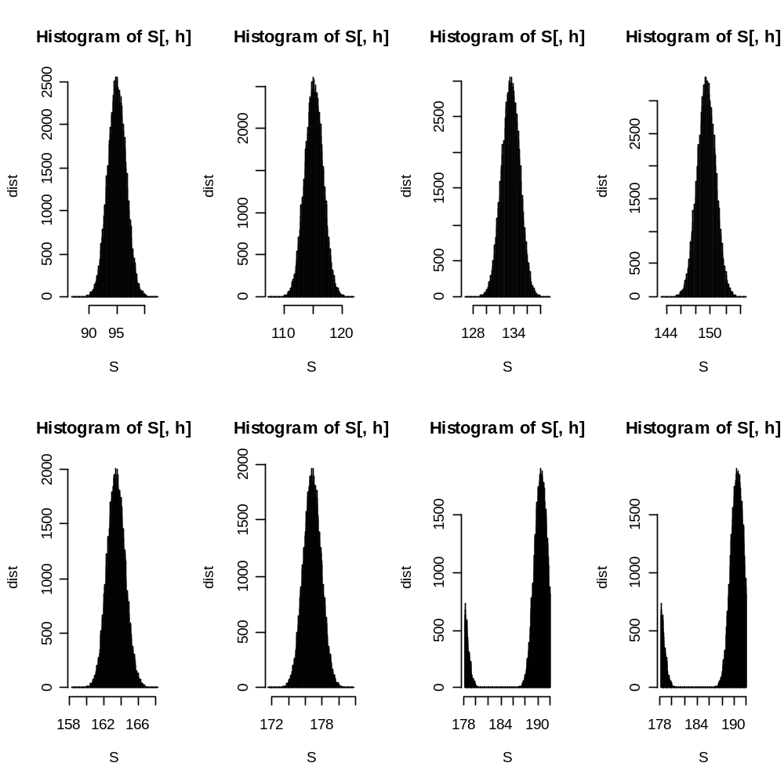
Distribution of sizes over years with each molting is given as above. S7, S8 are skewed, because many of the crabs reach old age and they don’t grow any further, so the break.
Means of growth simulation is plotted is :
Mean of S 1 ,S2,S3,S4,S5,S6,S7,S8 is : 99.407, 115.15,133.55,149.4199,163.43,176.836,189.254,189.254
SD of S 1 ,S2,S3,S4,S5,S6,S7,S8 is
### part E ###########
Prob that crab molted i times is P(molt=i)

Baeys theorem

Prob that crab molted i times given size X = P(molt=i/X)

So prob that crab molted 1 time given size X = p(molt=1/X) = p(X/molt=1) /summation over i (p(X/molt=i)
,i runs from 1 to inf (8 in above case since growth matures after approximately 8 moldings) as listed above.
A sample for atleast for size of x= 90 once gives the values : 0.45.
X=95 gives value of 0.47
Similarly all other values can be populated using the given for loop below.

Code :
means <- c(99.407, 115.15,133.55,149.4199,163.43,176.836,189.254,189.254)
sds <- c(1.600167,1.57355,1.327530,1.215489,1.029979,1.055073,3.561221,3.561221)
size <- seq(100:160,by=5)
prob <- rep(0,length(size))
for (l in 1 : length(size)){
sum<-0
for ( y in 1 : 8 ) {
sum <- sum + pnorm(size[l],means[y],sds[y])}}
prob <- array(0,dim =c(8,length(size)))
for (l in 1 : length(size)){
for (m in 1: 8 ) {
probk [l] <- pnorm(size[l],means[l]}}

Q3 .

Model :
- Dependent Variable is Claim frequency. Rest all other variables will be taken up as independent variables and a generalized linear model regression is done on given data, to find the claim frequency.
- Now the claim frequency is taken as a Poisson parameter to find the associated probability of a particular number of claims for that particular segment of the policy. Now relaxing the Poisson assumption due to finite number of policies. Lambda = n *P , in which p gives the probability of a policy getting claimed.

########## part a ############
Doing a linear regression by using dummy variables as follows
Kilometers : km[1-4] , with 1 as 0000, 2 as 0001 , 3 as 0010, 4 as 0100, 5 as 1000
Zone as : z[1-7], with 1 as 000000, 2 as 000001, …. 7 as 100000
Make as : m[1-8] with 1 as 00000000, 2 as 00000001, … 9 as 10000000

Code :
mtin<-read.csv("C:\\satish\\IIMA\\Acads\\Term4\\AMDA\\End term\\Q3\\ETP3.csv")
attach(mtin)
names(mtin)
freq.lm <- lm(Claimfreq~ km1+km2+km3+km4+z1+z2+z3+z4+z5+z6+m1+m2+m3+m4+m5+m6+m7+m8+Bonus+Insured+Claims+Payment)
summary(freq.lm)
First Iteration : Summary
Estimate Std. Error t value Pr(>|t|)
(Intercept) 1.446e-01 8.134e-03 17.779 < 2e-16 ***
km1 2.647e-02 5.394e-03 4.908 9.90e-07 ***
km2 1.453e-02 5.366e-03 2.707 0.006837 **
km3 1.534e-02 5.324e-03 2.881 0.004000 **
km4 8.218e-03 5.326e-03 1.543 0.122959
z1 -5.024e-02 6.460e-03 -7.778 1.14e-14 ***
z2 -4.585e-02 6.318e-03 -7.258 5.47e-13 ***
z3 -4.005e-02 6.320e-03 -6.337 2.84e-10 ***
z4 -4.600e-02 6.343e-03 -7.252 5.68e-13 ***
z5 -3.079e-02 6.269e-03 -4.911 9.73e-07 ***
z6 -2.373e-02 6.256e-03 -3.793 0.000153 ***
m1 -8.929e-03 7.850e-03 -1.137 0.255470
m2 -2.223e-03 7.171e-03 -0.310 0.756598
m3 8.594e-03 7.140e-03 1.204 0.228838
m4 -2.085e-02 7.118e-03 -2.929 0.003438 **
m5 1.652e-02 7.118e-03 2.321 0.020378 *
m6 -4.148e-02 7.186e-03 -5.772 8.95e-09 ***
m7 -1.754e-02 7.132e-03 -2.460 0.013965 *
m8 4.799e-03 7.108e-03 0.675 0.499655
Bonus -1.213e-02 8.583e-04 -14.135 < 2e-16 ***
Insured -1.311e-06 1.024e-06 -1.281 0.200367
Claims -3.493e-05 1.065e-04 -0.328 0.742872
Payment 1.557e-08 2.421e-08 0.643 0.520155
Based on vif values > 4.
So removing m1,m2,m3,m8,k m8, claims, payment, insured, sequentially , the following summary is obtained.
Estimate Std. Error t value Pr(>|t|)
(Intercept) 0.151472 0.006102 24.824 < 2e-16 ***
km1 0.021793 0.004629 4.708 2.66e-06 ***
km2 0.009833 0.004603 2.136 0.032756 *
km3 0.011162 0.004578 2.438 0.014835 *
z1 -0.051590 0.006365 -8.105 8.69e-16 ***
z2 -0.046654 0.006252 -7.463 1.22e-13 ***
z3 -0.041122 0.006262 -6.567 6.40e-11 ***
z4 -0.046049 0.006252 -7.366 2.49e-13 ***
z5 -0.031338 0.006252 -5.013 5.81e-07 ***
z6 -0.024070 0.006252 -3.850 0.000121 ***
m4 -0.022433 0.005505 -4.075 4.76e-05 ***
m5 0.015006 0.005505 2.726 0.006460 **
m6 -0.043324 0.005563 -7.788 1.04e-14 ***
m7 -0.019107 0.005523 -3.459 0.000552 ***
Bonus -0.012179 0.000840 -14.499 < 2e-16 ***

For cleaning up the outliers ::

Code for part d
pay.lm <- lm(Payment~ km1+km2+km3+km4+z1+z2+z3+z4+z5+z6+m1+m2+m3+m4+m5+m6+m7+m8+Bonus+Insured+Claims+Claims)
summary(pay.lm)
pay.lm <- lm(Payment~ km1+km2+km3+km4+z2+z4+m6+Bonus+Insured+Claims+Claims)
summary(pay.lm)
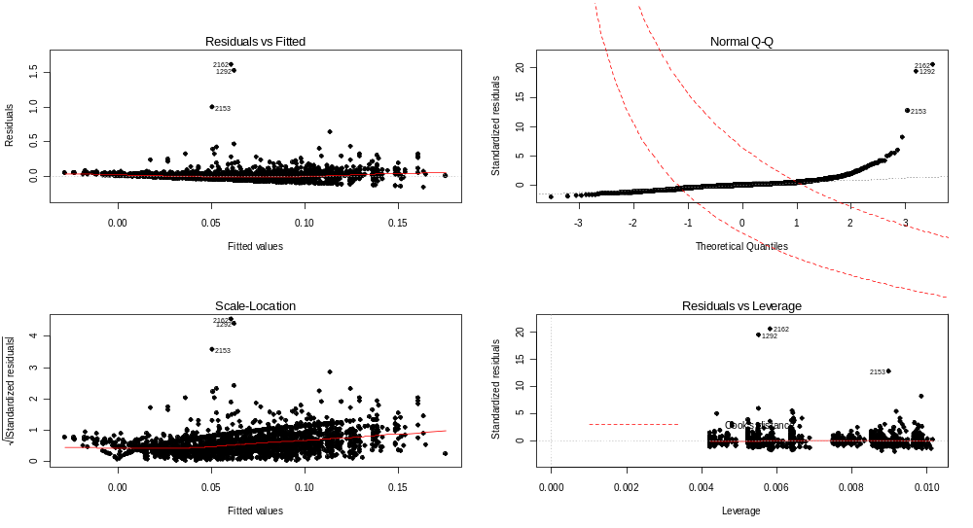

Sequentially cleaning up : 2162,1292,2153,
I can observe some heteosckedascticity and I also tried GAM/GLM models, but with dummy variable, smoothening of variables is becoming a problem. So I am proceeding with normal linear regression model.

GAM model with smoothening is as follows :
Claimfreq ~ km1+km2+km3+z1+z2+z3+z4+z5+z6+m1+m2+m4+m5+m6+m8+Bonus+s(Insured)+s(Claims)+s(Payment)

Estimate Std. Error t value Pr(>|t|)
(Intercept) 0.1349143 0.0050432 26.752 < 2e-16 ***
km1 0.0159512 0.0036490 4.371 1.29e-05 ***
km2 0.0111545 0.0035640 3.130 0.001773 **
km3 0.0074310 0.0034273 2.168 0.030254 *
z1 -0.0525900 0.0050647 -10.384 < 2e-16 ***
z2 -0.0378424 0.0047534 -7.961 2.74e-15 ***
z3 -0.0321436 0.0047560 -6.758 1.79e-11 ***
z4 -0.0406237 0.0048435 -8.387 < 2e-16 ***
z5 -0.0257715 0.0046769 -5.510 4.01e-08 ***
z6 -0.0208975 0.0046228 -4.521 6.50e-06 ***
m1 -0.0139433 0.0062424 -2.234 0.025608 *
m2 0.0088592 0.0043889 2.019 0.043660 *
m4 -0.0150228 0.0043077 -3.487 0.000498 ***
m5 0.0239023 0.0042784 5.587 2.61e-08 ***
m6 -0.0271036 0.0043967 -6.165 8.42e-10 ***
m8 0.0134897 0.0042725 3.157 0.001614 **
Bonus -0.0108858 0.0007357 -14.796 < 2e-16 ***

edf Est.rank F p-value
s(Insured) 9.000 7 6.440 1.59e-07 ***
s(Claims) 3.949 8 2.714 0.00564 **
s(Payment) 8.690 9 4.567 5.49e-06 ***

Performance of the model from summary statistics shows that Adjusted R2 is 0.26, which is bad.

#### part b ########
Probability of a claim does depend on the make,since m4-m7 coefficients are significant. All other makes are not fully relevant.

######### part C #########
Coefficeints of km1, km2, km3 are significant, showing that for kms > 25000, , 20k-25k, 15-20k are very much relevant in the probability of a claim.

########### part d ###########
Model : Dependent variable : Payment. Rest of all variables (some dummy) : independent.
Assumptions : 1. Payment depends on no of claims arising and the amount of each claim
- No of claims depends no of kms run, and zone in which it operates, and the credibility of driver as dependent on bonus rating.
- Amount of each claim in turn can depend upon how costly the car is , and it depends upon make of car

Initial summary :
Estimate Std. Error t value Pr(>|t|)
(Intercept) -1.551e+04 7.229e+03 -2.145 0.032058 *
km1 2.182e+04 4.781e+03 4.564 5.30e-06 ***
km2 2.187e+04 4.750e+03 4.605 4.36e-06 ***
km3 2.340e+04 4.712e+03 4.967 7.34e-07 ***
km4 2.231e+04 4.713e+03 4.734 2.35e-06 ***
z1 5.291e+03 5.761e+03 0.918 0.358529
z2 1.950e+04 5.604e+03 3.480 0.000511 ***
z3 6.764e+03 5.620e+03 1.204 0.228894
z4 3.293e+04 5.598e+03 5.884 4.64e-09 ***
z5 3.918e+03 5.575e+03 0.703 0.482253
z6 1.408e+03 5.565e+03 0.253 0.800329
m1 -8.172e+03 6.981e+03 -1.171 0.241881
m2 -9.856e+03 6.375e+03 -1.546 0.122237
m3 -1.996e+04 6.350e+03 -3.144 0.001690 **
m4 -1.850e+04 6.326e+03 -2.925 0.003478 **
m5 -1.796e+04 6.319e+03 -2.842 0.004527 **
m6 -2.627e+04 6.367e+03 -4.127 3.82e-05 ***
m7 -1.263e+04 6.338e+03 -1.993 0.046376 *
m8 -1.510e+04 6.314e+03 -2.392 0.016838 *
Bonus 1.377e+03 7.629e+02 1.804 0.071316 .
Insured 2.816e+01 6.794e-01 41.450 < 2e-16 ***
Claims 4.292e+03 2.072e+01 207.165 < 2e-16 ***

Cleaning up : z1,z3,z5,z6,m1,m2,m3,
So the final model is Payment~ km1+km2+km3+km4+z2+z4+m6+Bonus+Insured+Claims
With the coefficients listed down

Estimate Std. Error t value Pr(>|t|)
(Intercept) -1.972e+04 3.557e+03 -5.544 3.32e-08 ***
km1 2.221e+04 4.777e+03 4.649 3.54e-06 ***
km2 2.223e+04 4.750e+03 4.679 3.06e-06 ***
km3 2.356e+04 4.720e+03 4.992 6.45e-07 ***
km4 2.226e+04 4.720e+03 4.717 2.54e-06 ***
z2 1.606e+04 4.326e+03 3.713 0.00021 ***
z4 2.908e+04 4.350e+03 6.683 2.96e-11 ***
m6 -1.326e+04 4.820e+03 -2.751 0.00599 **
Insured 2.824e+01 6.423e-01 43.969 < 2e-16 ***
Claims 4.296e+03 1.809e+01 237.491 < 2e-16 ***

Adjusted R2 is 99.53, so the fit is very good.

## part e ########
Validation : only z2/z4,m6 are significant, and other zones/segements are insignificant.

So final payment depends on (i) make of car, (m6) and (ii) whether car falls in 5,4,3 zones

## part f ############

Premium should be charged based on the amount at risk which depends on total claim amount
Claim amount = no of claims * amount/claim
= no of policies * probability of claim * payment/claim
Last two factors are obtained for all the existing policies.
For eg: if no of policies = 1000, across various segements, then we will generate the probability of claim for each of the policy and the payment amount as well, to calculate the amount at premium amount

For a particular segment :
Prob of claim = 0.65,
Payment amount = 1000
No of existing policies =50
Sor premium per policy = 50*0.65*1000
For risk neutrality : 0.65*1000*50 = (1-0.65)*50*premium
- Premium = (0.65/0.35)*1000 = 1857

Q4

Model : independent variables : independence index , legal index, and development status
Dependent var : inflation
infl.lm <- lm(INF ~ QUES+LEGAL+DEV)

First iteration summary:
Estimate Std. Error t value Pr(>|t|)
(Intercept) 60.7550 18.3957 3.303 0.00396 **
QUES -4.2035 3.2823 -1.281 0.21657
LEGAL -0.1394 4.7868 -0.029 0.97708
DEV -23.5736 13.2568 -1.778 0.09226 .

Removing legal index , and removing a couple of outliers (Peru and Ethiopia) at 5% level of significance gives the following model

Final model is as follows: INF = 62.909 -21.62 * DEV-4.854*QUES
Estimate Std. Error t value Pr(>|t|)
(Intercept) 62.909 12.530 5.021 0.000105 ***
QUES -4.854 2.210 -2.197 0.042173 *
DEV -21.692 7.756 -2.797 0.012386 *

Multiple R-squared: 0.5933, Adjusted R-squared: 0.5454
F-statistic: 12.4 on 2 and 17 DF, p-value: 0.0004777
Also vif values are below 4.0, so there is no multicollinearity
QUES 1.324 ; DEV : 1.324
Since R2 is less 60% , regression fit is acceptable but not good.
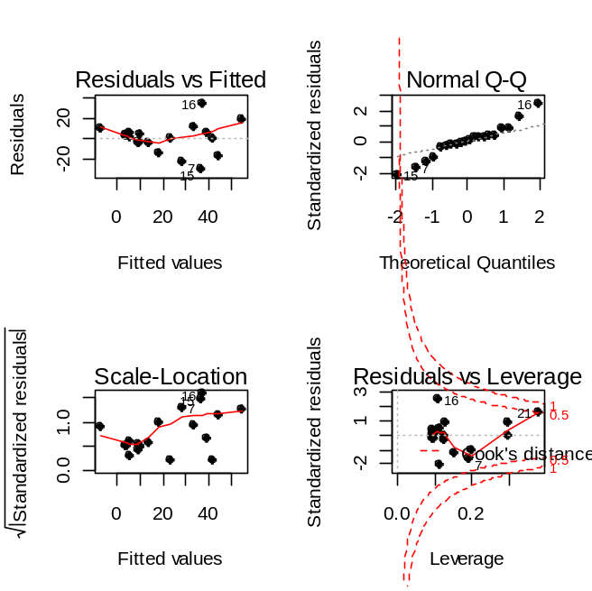

### part b ########

Developed Countries :
Model : inf = 9.98+0.08*QUES-.879*LEGAL,
Diagnostics :
Estimate Std. Error t value Pr(>|t|)
(Intercept) 9.98985 5.43559 1.838 0.103
QUES 0.08316 1.03620 0.080 0.938
LEGAL -0.87919 0.93927 -0.936 0.377

Even if I removed QUES, LEGAL only has p_value of 0.21, And since R2 is -0.04, which shows model fit is not acceptable at all.

Developing Countries : After cleaning up peru and Ethiopia
Model : inf =89.384-5.373*QUES-6.344*LEGAL

Diagonistics :
Estimate Std. Error t value Pr(>|t|)
(Intercept) 89.429 30.076 2.973 0.0248 *
QUES -5.373 5.545 -0.969 0.3700
LEGAL -6.344 10.029 -0.633 0.5504

Even if I removed LEGAL, QUES only has a pvalue of 0.10, and R2 is 0.2418, so the model fit is not acceptable.

## part C #########
Not deleting the outliers in part a , since gam model can fit reasonable outliers using spline methods.

GAM model: INF ~ s(QUES)+s(LEGAL)+DEV)
We are not smoothing the development status due to lesser no of unique values.
Initial summary :
Parametric coefficients:
Estimate Std. Error t value Pr(>|t|)
(Intercept) 35.810 6.316 5.670 0.000101 ***
DEV -23.074 10.426 -2.213 0.046837 *
---
Signif. codes: 0 ‘***’ 0.001 ‘**’ 0.01 ‘*’ 0.05 ‘.’ 0.1 ‘ ’ 1

Approximate significance of smooth terms:
edf Est.rank F p-value
s(QUES) 6.896 9 3.037 0.0377 *
s(LEGAL) 1.000 1 0.172 0.6852
---
Signif. codes: 0 ‘***’ 0.001 ‘**’ 0.01 ‘*’ 0.05 ‘.’ 0.1 ‘ ’ 1

R-sq.(adj) = 0.655 Deviance explained = 80.1%
GCV score = 508.45 Scale est. = 279.75 n = 22

Removing Legal variable.
(Intercept) 34.877 5.654 6.168 3.53e-05 ***
DEV -21.209 8.998 -2.357 0.0349 *
---
Signif. codes: 0 ‘***’ 0.001 ‘**’ 0.01 ‘*’ 0.05 ‘.’ 0.1 ‘ ’ 1

Approximate significance of smooth terms:
edf Est.rank F p-value
s(QUES) 7.125 9 3.424 0.0225 *
R-sq.(adj) = 0.682 Deviance explained = 80.5%
GCV score = 440.95 Scale est. = 258.05 n = 22

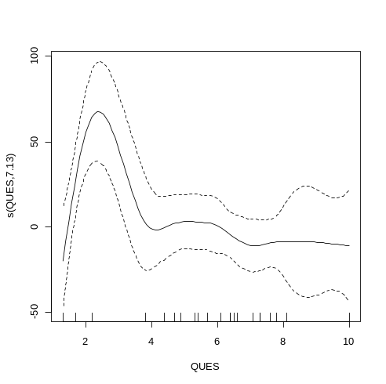
So spline fit for QUES is as above.

## Part D ########

Since we are testing for linearity, the coefficients of residual fit should be zero, and the p_Values should be close to 1, and coefficients are insignificant. In the current fit, diagnostics are as follows.
Coefficients:
Parametric coefficients:
Estimate Std. Error t value Pr(>|t|)
(Intercept) -3.482 6.181 -0.563 0.581
DEV 3.529 9.579 0.368 0.717

Approximate significance of smooth terms:
edf Est.rank F p-value
s(QUES) 1.450 3 0.789 0.517
s(LEGAL) 1.000 1 0.032 0.861

Since the p_values are close to 1, we can say all components of GAM model are insignificant, and there is linearity of regression in part a.

##### part e #############

Simply by looking at annual inflation rate, it will not be possible to distinguish a country, because
For developed countries range of inflation rate is 3-14, while it is 108-6 for developing countries. So if a particular countries inflation rate is between 6 and 14, then we will not be able to classify it properly.

Developed mean : 7.545, std dev : 3.01
Developing mean : 54.25, std dev : 28.33 ( after removing 3 very low inflation rates)

Assuming normal distribution of annual inflation rates , and the tendency of developed countries inflation to be low, while that of developed countries is high (need to be proved statistically as well).
For a 5% level of significance one sided range for developed countries = 7.545+1.64*3.01 = 12.474
Similarly for developed countries = 54.25.64*28.33= 7.78

So there is still some uncertainity , so taking a mid value of 10.125, we will arrive at ~ 90% level of significance

So if inflation rate is > 10.125, it’s a developing country and if less then developed country. But this model is very naïve, and is not accurate.

2 model : We will develop a logistic regression model

Dependent variable : dev
Independent variable : annual inflation rate, legal and independence indices.

Model : y =3.1563-.2044*INF
Diagnostics :
Coefficients:
Estimate Std. Error z value Pr(>|z|)
(Intercept) 3.1563 1.3544 2.330 0.0198 *
INF -0.2044 0.1128 -1.812 0.0700 .
---
Signif. codes: 0 ‘***’ 0.001 ‘**’ 0.01 ‘*’ 0.05 ‘.’ 0.1 ‘ ’ 1

(Dispersion parameter for binomial family taken to be 1)

Null deviance: 27.526 on 19 degrees of freedom
Residual deviance: 13.068 on 18 degrees of freedom
AIC: 17.068

Threshold is 0.185 (determined as in Q1)
Performance : And the misclassification errors is 2 out of 20, which is 10%

Q5 .
I separated out male/female smokers/non-smokers and then ran the linear regression.

Code : freq.lm <- lm(Rate ~ Age+sex+Smoke)
Diagnostics :
Estimate Std. Error t value Pr(>|t|)
(Intercept) -572.6630 40.7280 -14.061 < 2e-16 ***
Age 16.6613 0.8956 18.603 < 2e-16 ***
sex 49.5652 11.8816 4.172 7.07e-05 ***
Smoke 86.5217 11.8816 7.282 1.32e-10 ***
Residual standard error: 56.98 on 88 degrees of freedom
Multiple R-squared: 0.8256, Adjusted R-squared: 0.8196
F-statistic: 138.8 on 3 and 88 DF, p-value: < 2.2e-16

All p_values are accepatable even at 1% level of significance. And R2 of 0.8196 , shows a good fit.,Vif : shows 1,1,1 for all variables, which is below 4, so model doesn’t have multicollinearity, BUT, a look at the plots shows that we definetly required transformation of variables, and the fit is not GOOD, as normality assumption of residuals is true, and we can observe specific patterns.
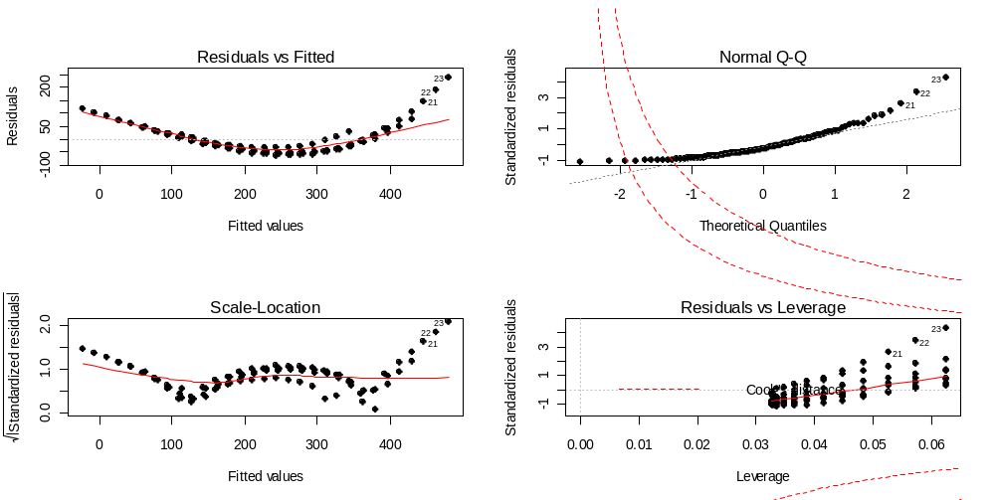
We can clearly see the segments of scatter of smokers and non-smokers and male female residuals vs fit plot. So model doesn’t accularately describe the data.
######### part B##########

### par t C ########

GAM model : freq.gam <- gam(Rate ~ s(Age)+sex+Smoke)
We can smoothen digital variables, since they don’t have many unique values, an covariate matrix if not big enough to smoothen the values.
Diagnostics
Parametric coefficients:
Estimate Std. Error t value Pr(>|t|)
(Intercept) 160.435 7.248 22.136 < 2e-16 ***
sex 49.565 8.369 5.923 6.39e-08 ***
Smoke 86.522 8.369 10.338 < 2e-16 ***
---
Signif. codes: 0 ‘***’ 0.001 ‘**’ 0.01 ‘*’ 0.05 ‘.’ 0.1 ‘ ’ 1

Approximate significance of smooth terms:
edf Est.rank F p-value
s(Age) 3.187 7 110.9 <2e-16 ***
---
Signif. codes: 0 ‘***’ 0.001 ‘**’ 0.01 ‘*’ 0.05 ‘.’ 0.1 ‘ ’ 1

R-sq.(adj) = 0.911 Deviance explained = 91.6%
GCV score = 1727 Scale est. = 1610.9 n = 92

All p_values are lower than 1% and R2, as well as well as Deviance as at 91%, which shows model is a good fit. Smoothening is as follows.
